Abstract, A guideline to how the abstract should look like, when submitted to the Scientific committee, not later than 10 November 2024 for the annual conference 30 January 2025 (Calibri 14, bold)

*J.G. Dannisøe, Danish Water Forum*, P.E. Holm**, KU-PLEN, HJ. Albrechtsen, DTU Environment*** (Calibri 10, Italic)*

**Abstract**

Dear author.

We suggest that you build your abstract according to the headings below:

Please follow this WORD format, when you submit your abstract to the organising committee. It will help us a lot in joining all abstracts to a booklet. **DO NOT** **SUBMIT IN PDF**.

**Your abstract must NOT exceed 1 page in total,** covering names of authors, pictures and text. When adding pictures, please compress them to a suitable level to avoid very heavy files. **DO NOT CHANGE FONT in the main text** (Calibri 10).

**The meeting will take place 30 January 2025 at Aarhus University, Stakladen.** Your presentation at the meeting should also be with compressed pictures to avoid heavy files. Send the abstract in WORD to the Scientific committee through Jesper G. Dannisøe, DWF at [dwf@danishwaterforum.dk](mailto:dwf@danishwaterforum.dk) with a copy to [jda@dhigroup.com](mailto:jda@dhigroup.com) : SUBJECT TITLE: **ABSTRACT!**

**Please expect that you will have approx. 10 minutes for your presentation.**

**Introduction**: State your subject and the context

**Methods and data**: State what was used as data and tools

**Results**: Key results from the research/work

**Discussion and take-home message**: 2-3 key finding and how to apply the results and how to use them.

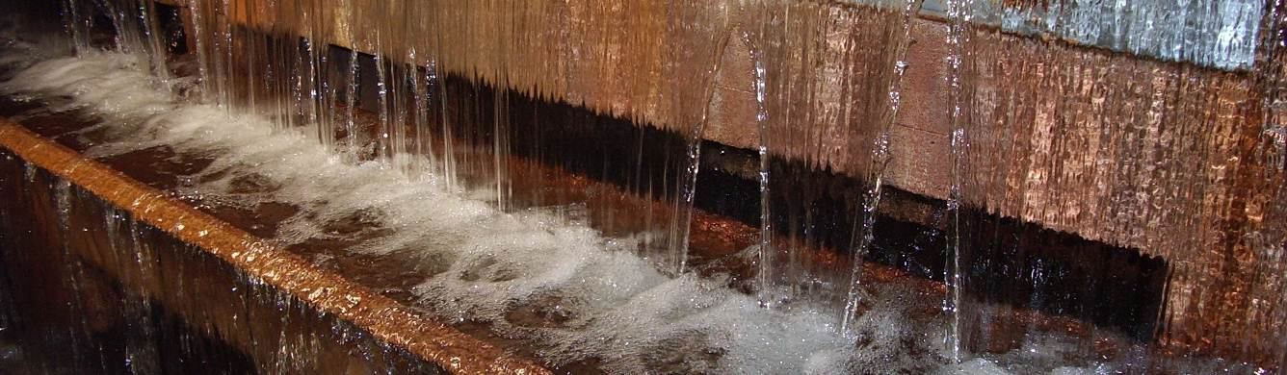

*\** [*jda@dhigroup.com*](mailto:jda@dhigroup.com)*: Agern Allé 5, DK-2970 Hørsholm, Denmark*

*\*\** [*peho@plen.ku.dk*](mailto:peho@plen.ku.dk)*: Thorvaldsensvej 40, 1871 Frederiksberg C*

*\*\*\** [*hana@env.dtu.dk*](mailto:hana@env.dtu.dk) *: Bygningstorvet, Bygning 115, 2800 Lyngby*